**AUTOMATED TEXT SUMMARIZATION**

**User Interface**

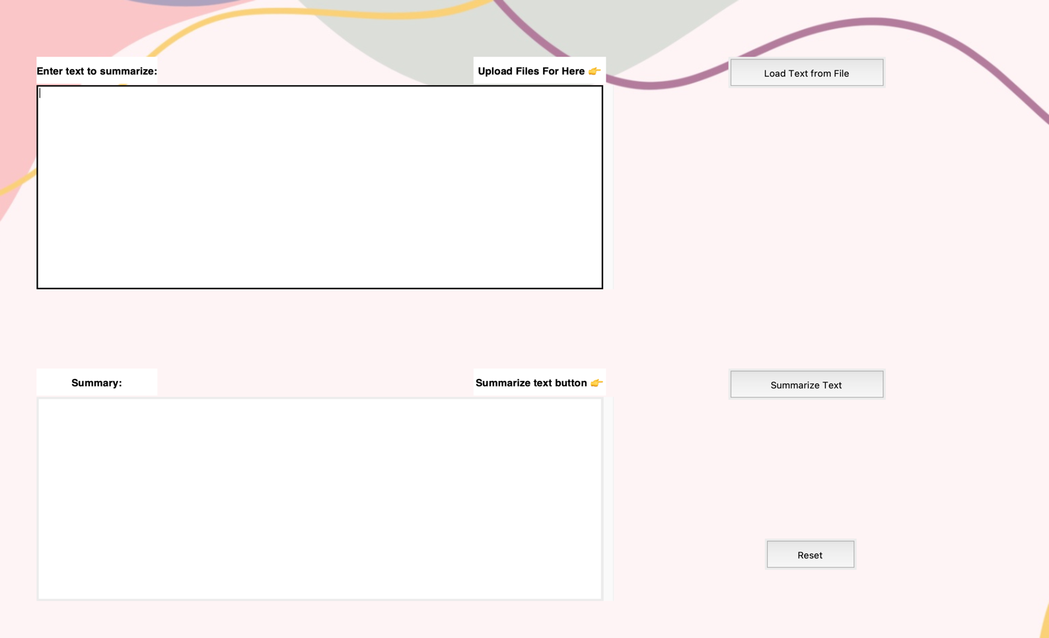

**Enter the text in first box that you need to summarize.**

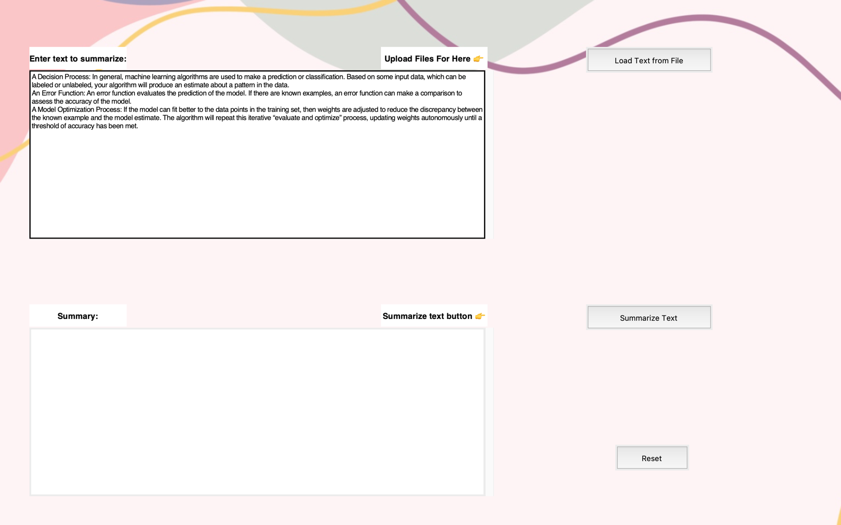

**After entering the text click on the summarize text button give.**

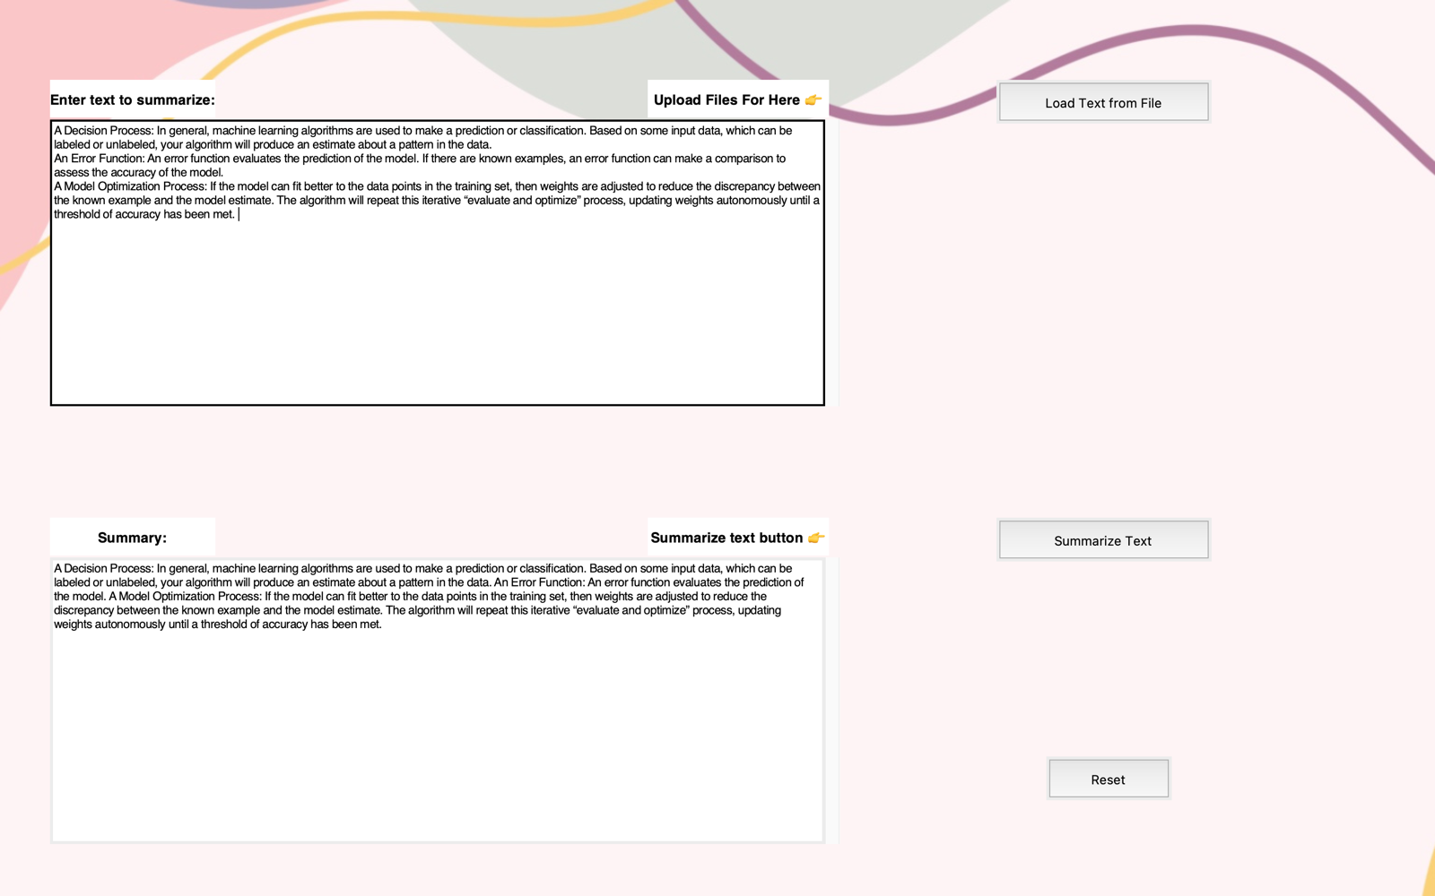

You will get the summary of your text here

Click here

**To enter the new text for summary Click the reset button at the bottom.**



Click here to Reset

**After clicking reset button it will be clear all the text in it.**

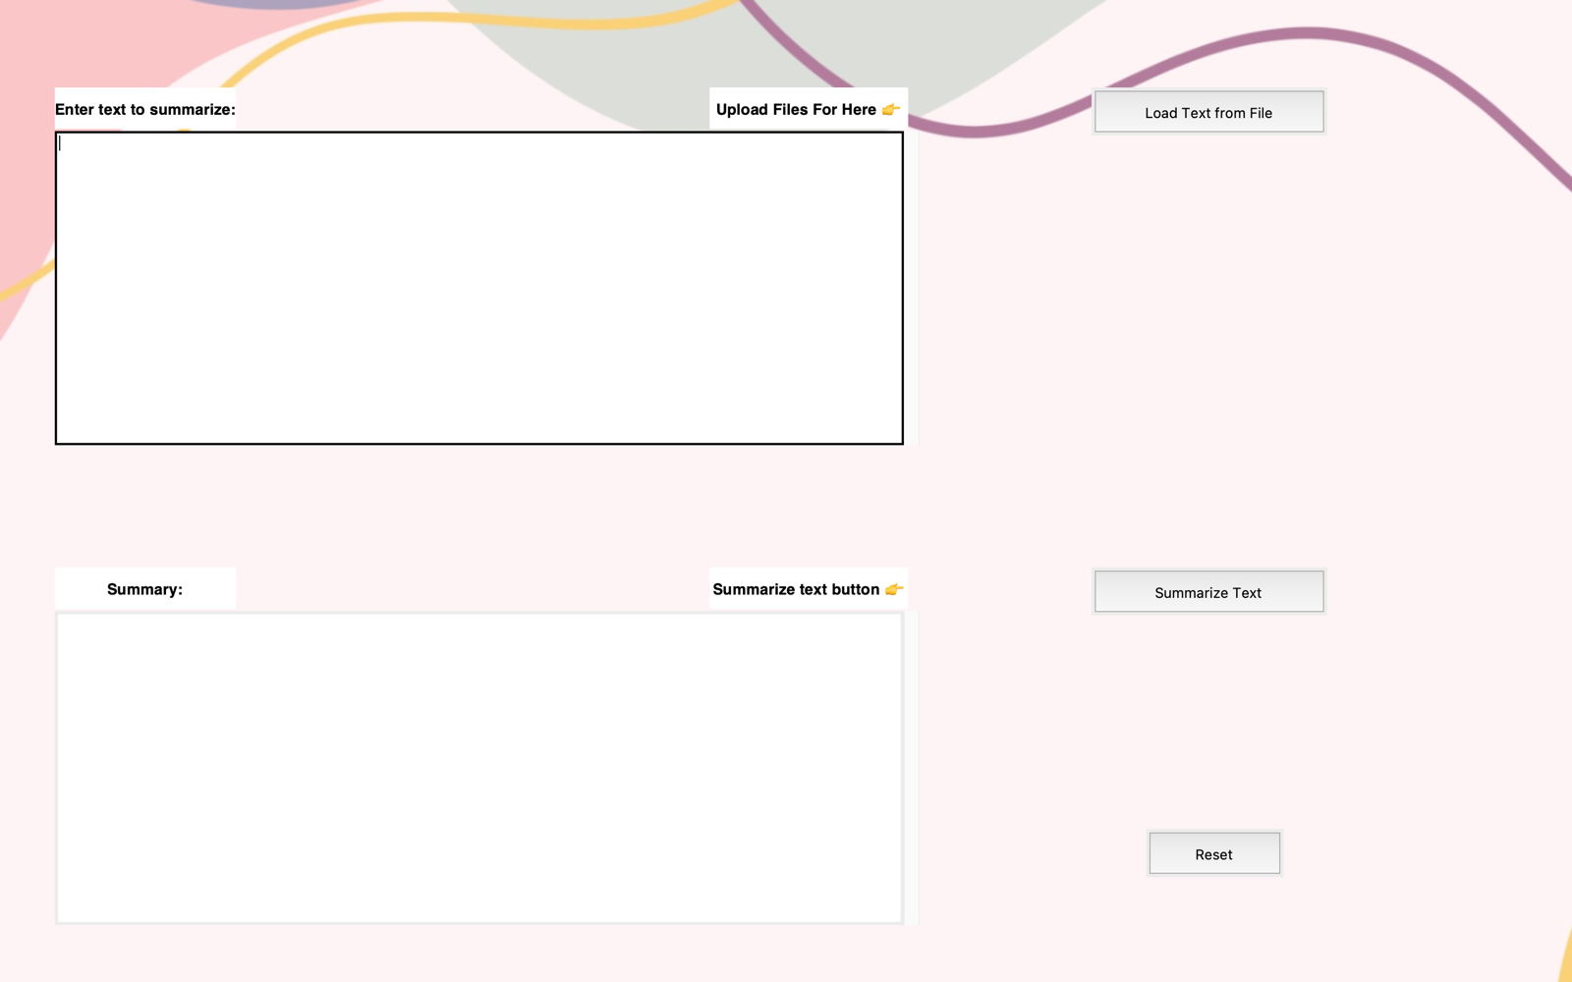

**This interface having another option to summarize the text it is user can upload the TXT or DOCX files to get summary .**



Click here

**Select the file for your device.**

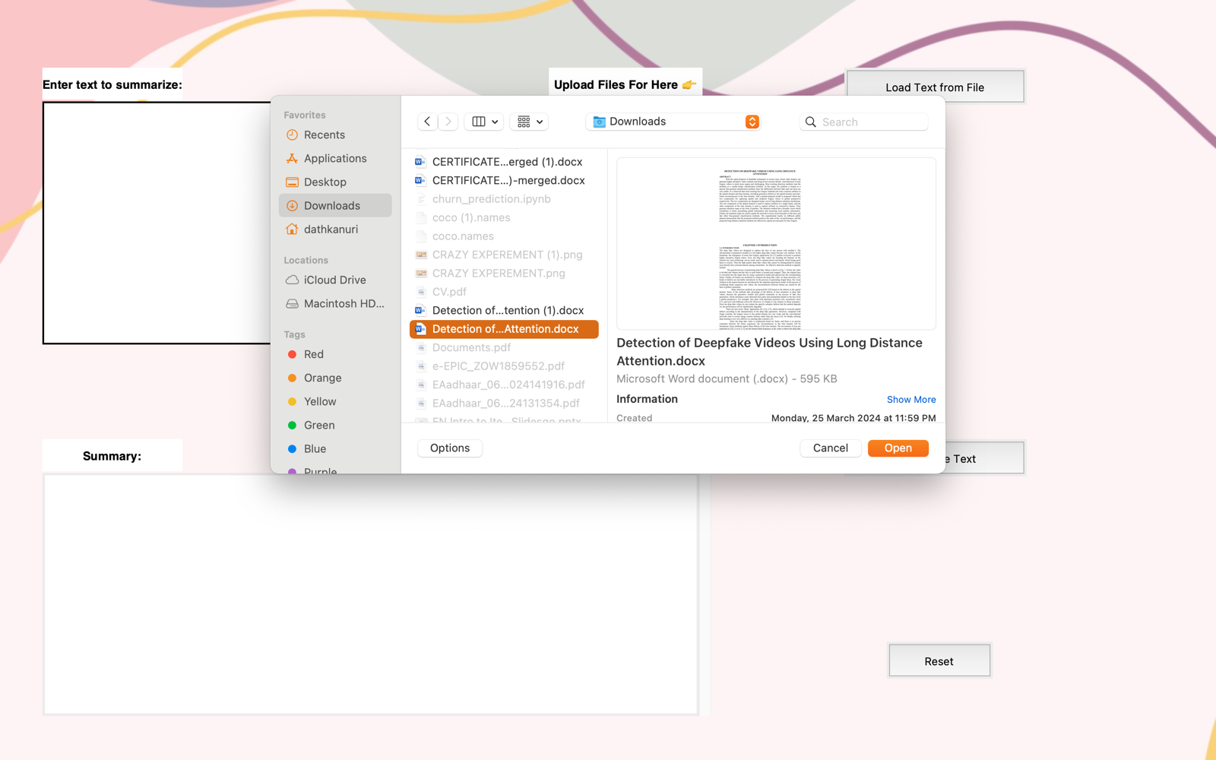

**It will summarize the text in file that uploaded by the user.**

